**Department of Romance Studies and Classics**

**Fact** **Sheet**

**Academic Year 2024/2025**

|  |  |
| --- | --- |
| **THE UNIVERSITY – A PRESENTATION** |  |
| **ERASMUS code** | S STOCKHO01 |
| **ECHE number** | 29366-EPP-1-201-1-SE-EPPKA3-ECHE |
| **Faculties** | * Faculty of Humanities * Faculty of Law * Faculty of Natural Sciences * Faculty of Social Sciences |
| **Number of students** | + 29 000 |
| **Website** | <https://www.su.se/english/> |
| **Facilities** | * Library * Sport Hall * Computer rooms * Staff and student restaurants * Academic Writing Support |

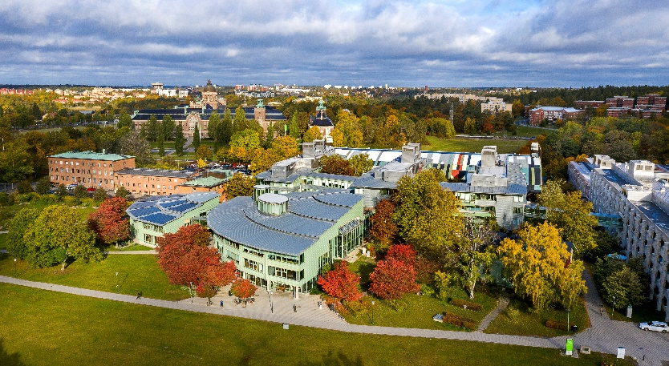

|  |  |
| --- | --- |
| **DEPARTMENT OF ROMANCE STUDIES AND CLASSICS**  **(Faculty of Humanities)** |  |
| **Departmental coordinators**  **Contact persons for incoming and outgoing exchange students within departmental agreements at the Department of Romance Studies and Classics** | * Hans-Roland JOHNSSON   - agreements France and Belgium  E-mail: [international.romklass@su.se](mailto:international.romklass@su.se)   * Anne-Cathrine LAURELL   – agreements Italy and Latin American Studies  E-mail: [international.romklass@su.se](mailto:international.romklass@su.se)   * Gunnel NÄSMAN   – agreements Spain and Portugal  E-mail: [international.romklass@su.se](mailto:international.romklass@su.se) |
| **Postal address:**  **Visiting address:**  **Website:** | Stockholm University  Department of Romance Studies and Classics  106 91 Stockholm  Södra huset (South building), house B, 5th floor  https://www.su.se/romklass/english/ |

|  |  |
| --- | --- |
| **ACADEMIC CALENDAR** |  |
| **Autumn semester 2024**  **Spring semester 2025** | September 2nd - January 19th  January 20th – June 5th |

|  |  |
| --- | --- |
| **NOMINATION AND ADMISSION PROCEDURE** |  |
| **Nomination deadlines:**  Autumn semester: **May 1st**  Spring semester: **October 1st** | Nominations should be sent to:  [International.romklass@su.se](mailto:International.romklass@su.se) |
| **Students with a Disability** | Please observe that this has to be notified at the same time as the nomination. A document proving this from the sending institution is required.  The sending institution is responsible for covering all extra costs in connection with the exchange.  Info: [su.se/disability](http://www.su.se/disability) |
| **Application deadlines:**  Autumn semester: **May 10th**  Spring semester: **October 10th** | Applications should be sent to:  [International.romklass@su.se](mailto:International.romklass@su.se) |
| **Documents to submit with Application** | * Application Form with (preliminary) choice of courses – both course name and course code * Transcript of records * Copy of ID or passport (valid) * Copy of European Health Insurance card   NB this needs to be valid throughout the exchange period |
| **Learning Agreement** | * After the student has received confirmation from the departmental coordinator concerning the choice of all courses – an OLA (or LA) can be signed by the coordinator. |

|  |  |
| --- | --- |
| **LEVEL OF LANGUAGE REQUIRED** |  |
| **English** | Courses with English as language of instruction - B2 |
| **French/Italian**  **/Portuguese/Spanish** | Courses with French/Italian/Portuguese/Spanish as language of instruction - B2 |

|  |  |
| --- | --- |
| **ACADEMIC INFORMATION** |  |
| **Courses at the Department of Romance Studies and Classics** | The department offers courses with French, Spanish, Italian and Portuguese as language of instruction at Bachelor and Master level.  Some courses are given with English as language of instruction as well - in Romance Languages (Advanced level) and Latin American Studies.  **The incoming student is required to choose a minimum of 7,5 ECTS** at the Department of Romance Studies and Classics.  [www.su.se/romklass/courses](http://www.su.se/romklass/courses) |
| **Information Incoming Erasmus** | [www.su.se/department-of-romance-studies-and-classics/exchange](http://www.su.se/department-of-romance-studies-and-classics/exchange) |
| **Course catalogue**  **Stockholm University** | The student can narrow down the search by using filters, ex: choose semester, area of studies, level – ex: 1st level (Bachelor) - 2nd level, (Master), language of instruction etc.  <https://www.su.se/english/search-courses-and-programmes?q>= |
| **Choice of courses** | After receiving the Application Form, the departmental coordinator will contact the various Departments responsible for each course, to check if the student is eligible to the course.  The departmental coordinator at Romklass will inform the student as soon as possible.  **Exception:** All application to courses at the English department must be carried out directly to them by the student. Students wanting to apply for courses at the English department should contact the departmental coordinator at Romklass in order to get a link for information and application. |
| **Courses** | Normally 7,5, 15 or 30 credits.  Students can choose 1 course 30 credits, or two courses 15 credits courses, or four 7.5 credit courses - or any other combination.   * Courses can be offered daytime or late afternoon/evening. * Courses 7,5 – 15 credits are sometimes offered at slower pace 25-50%. * The workload is estimated to 40 hours per week for fulltime-studies (30 ECTS) including lectures, readings, assignments, seminars and independent studies. * All courses at SU have got a course plan, that states content, eligibility, examinations etc. Unfortunately, not all course plans are available in English.   For questions regarding eligibility and choice of courses please contact the departmental coordinator at the Department of Romance Studies and Classics. |
| **Choice of courses – practical information** | * The semester is divided into 2 periods, each period consists of 10 weeks of studies. * Preferably the student should choose 15 ECTS in each period. * Period 1 is divided into A and B, and period 2 is divided into C and D - by some departments. * The student should avoid choosing all courses during the same period. This may cause problems e.g. with workload, schedules and exams. |
| **Application**  **Periods** | * Courses starting autumn semester – **application spring** * Courses starting spring semester – **application autumn** * Students staying a whole academic year can carry out a preliminary choice for the 2nd semester. The departmental coordinator will contact the student in September/October for the choice of courses for spring. |
| **Required credits/ECTS** | * Exchange students are supposed to take 30 credits/semester which is considered studies at 100%. |
| **Examination** | * Examinations are arranged throughout the year with no fixed examination periods. Most often one re-take of an examination is offered within the course period, or shortly after. * Please observe that you need to sign up for many/most examinations via the digital platform Ladok for students (www.student.ladok.se) - **no later than 10 days before.**   If you miss this deadline, you will not be able to sit the exam. |
| **Grading system** | * A-F |
| **Official Transcript of records** | * Official Transcripts of Records will be sent to the home university approximately one month after the end of the semester. |

|  |  |
| --- | --- |
| **LEVEL OF LANGUAGE REQUIRED** |  |
| **English** | Courses with English as language of instruction - B2 |
| **French/Italian**  **/Portuguese/Spanish** | Courses with French/Italian/Portuguese/Spanish as language of instruction - B2 |

|  |  |
| --- | --- |
| **HOUSING ETC** |  |
| **General information about housing, insurance, T-number etc.** | <http://www.su.se/cmlink/stockholm-university/education/admissions/practicalities> |
| **Application procedure - Housing** | * The Departmental coordinator at the Department of Romance Studies and Classics will send the student’s contact information (e-mail) to the Housing Office. * The Housing Office will then contact all students by e-mail in mid/late May (arrival autumn) mid/late October (arrival spring) to inform about how to apply for housing.   **NB** Since the housing situation in Stockholm is rather difficult, please note that we cannot guarantee housing for all students.  However, students not receiving housing at first will be placed on a waiting list, and will also receive information from the Housing Office how to search for alternatives. |
| **Insurance** | All incoming exchange students are covered by Kammarkollegiet’s Student IN-insurance, by the Swedish state during the time that they are registered on courses as exchange students at Stockholm University. Please note that this insurance is only valid when being in Sweden. For any travels during the study period in other countries, it is recommended that students have a private insurance.  Read more about the insurance terms and conditions here: [kammarkollegiet.se/engelska/start/all-services/insurance-for-foreign-visitors/student-insurance/exchange-students-in-sweden](https://www.kammarkollegiet.se/engelska/start/all-services/insurance-for-foreign-visitors/student-insurance/exchange-students-in-sweden) |

|  |  |
| --- | --- |
| **USEFUL INFORMATION** |  |
| **Welcome Activities**  <https://www.su.se/english/education/a-smooth-start/welcome-activities> | Autumn: Normally the week before the autumn semester starts  Spring: Normally the same week as the spring semester starts   * Nominated students will receive information and an invitation from the central administration. * Program will be available on SU website approximately one month before. * Participation is optional, but we strongly recommend our exchange students to participate, especially at the Orientation Day. |
| **Swedish as a foreign language course** | Swedish language courses on different levels are offered for free by the Department of Swedish Language and Multilingualism to all incoming exchange students.  <https://www.su.se/svefler/english/education/courses-and-programmes/swedish-for-international-students>  Information about language courses will be given during the Welcome Activities. |
| **Getting around at the university** | [su.se/english/education/a-smooth-start/find-your-way-on-campus](http://www.su.se/english/education/a-smooth-start/find-your-way-on-campus)  Most courses are given at Frescati campus. |
| **General information about Stockholm university for international students** | <https://www.su.se/english/education/during-your-studies>  Information about the library, IT, Wifi etc. |
| **Student Health** | [su.se/studenthealth](http://www.su.se/studenthealth) |
| **Student Union – organizes activities for international students** | <https://www.en.sus.su.se/> |
| **Public transport in Stockholm** | <https://sl.se/en/>  The metro station for campus Frescati is « Universitetet » direction Mörby centrum (red line) |